|  |  |
| --- | --- |
| Course Name | ITD 2313 – Script Programming |
| Instructor | Greg Morris |
| Student Name | Mung Mang |
| Due date | 02/19/2023 |
| Grade | Put grade earned here |
| Grading Comments | Put instructor comments here |

Pg. 103

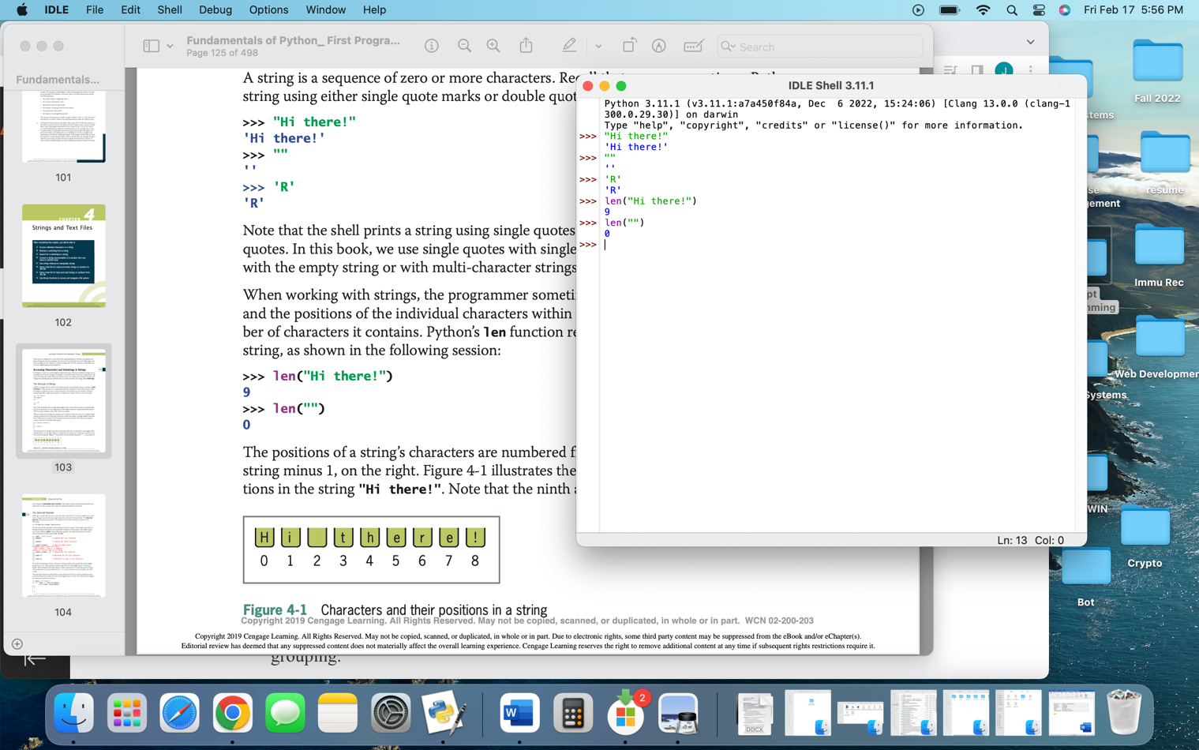

Pg. 104

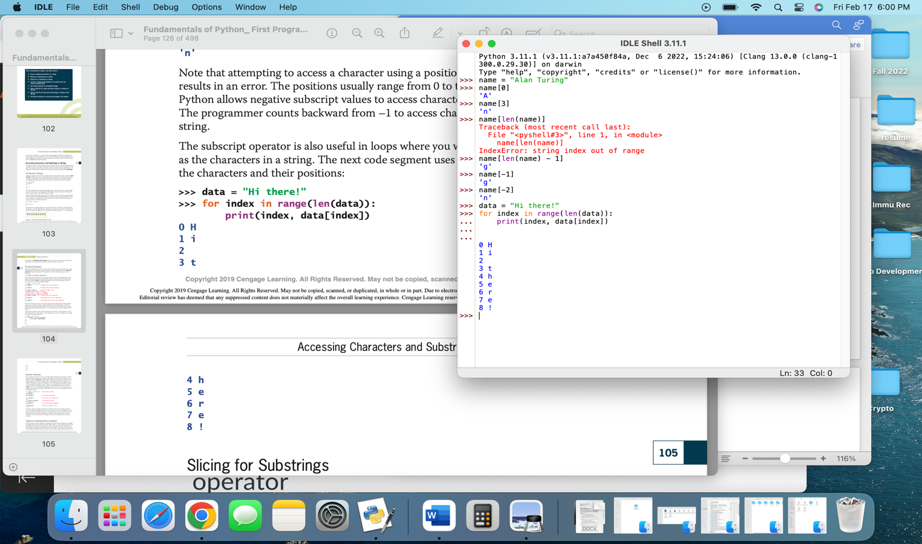

Pg – 106

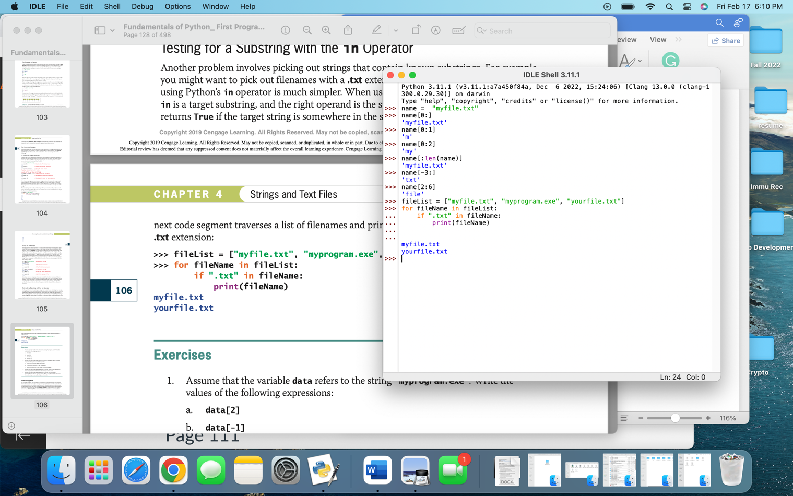

Pg 108

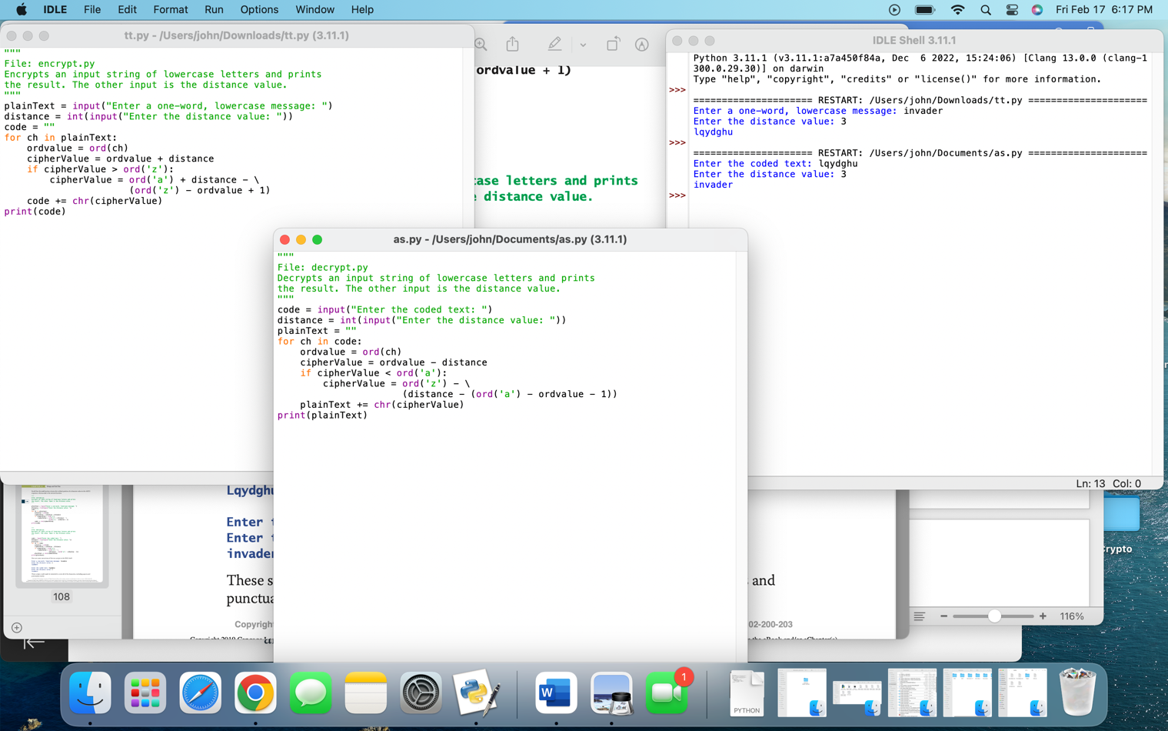

Pg 111

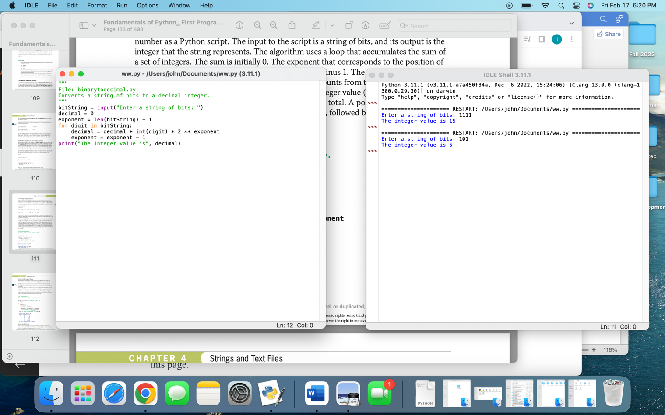

Pg 112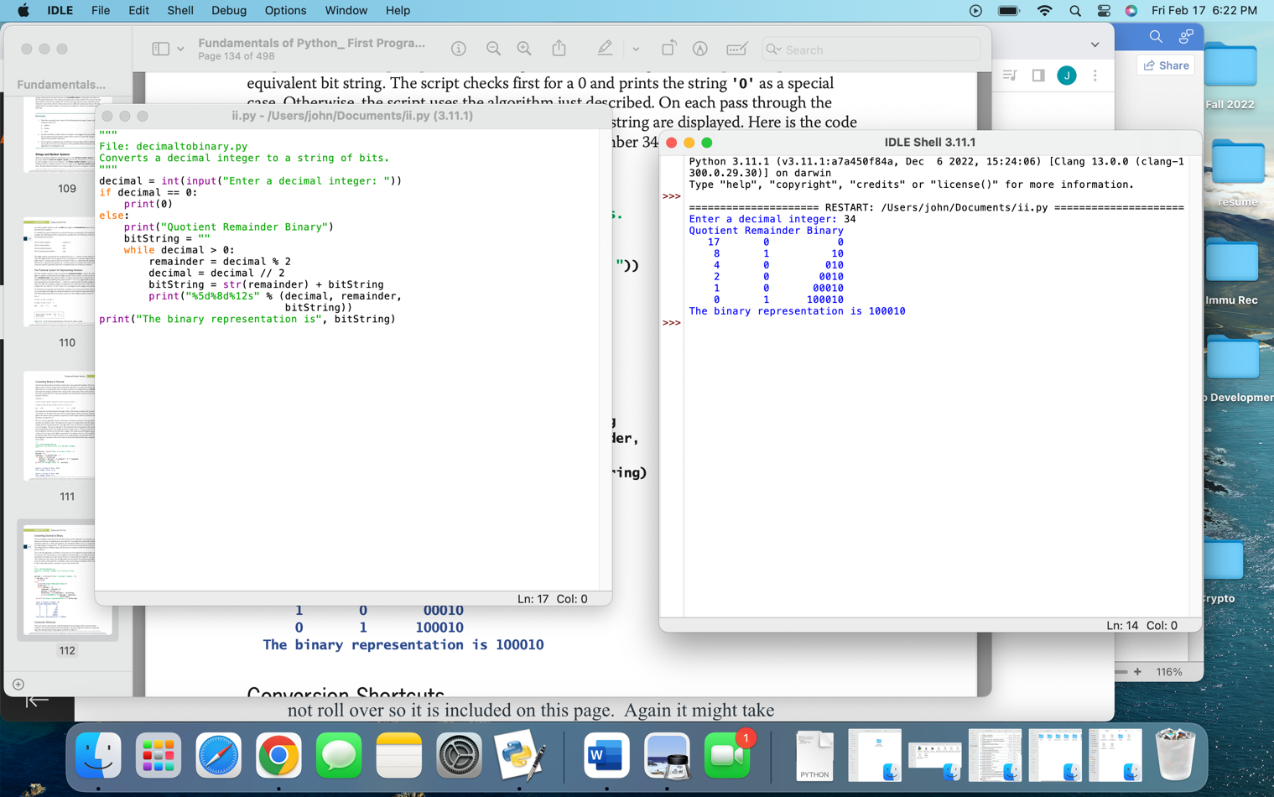

Pg 115

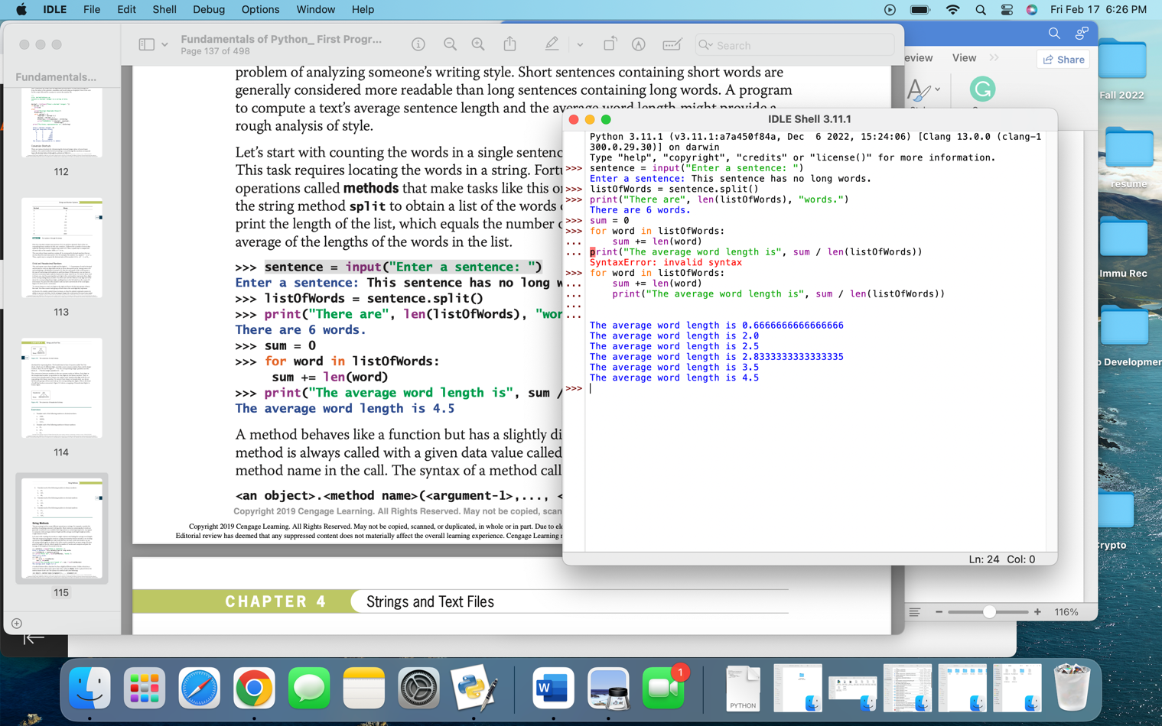

Pg 117

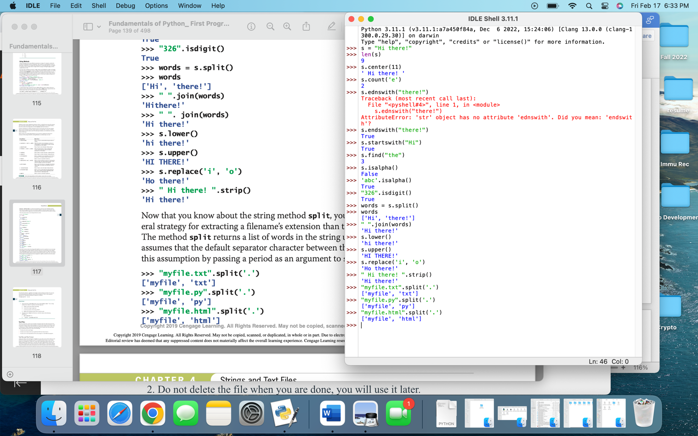

Pg 119

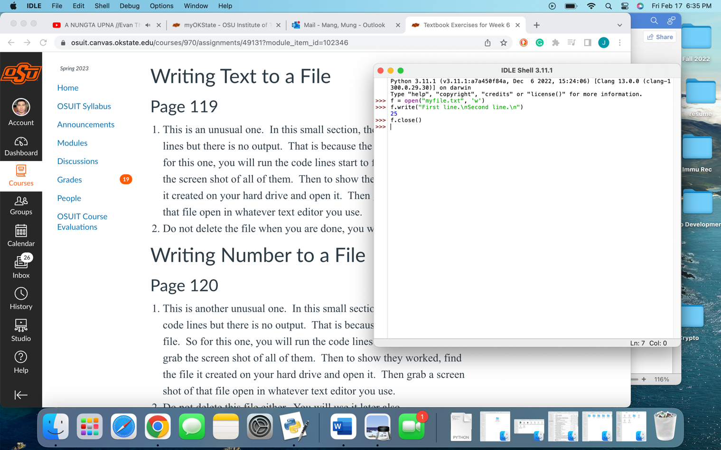

Pg 120 + 121

